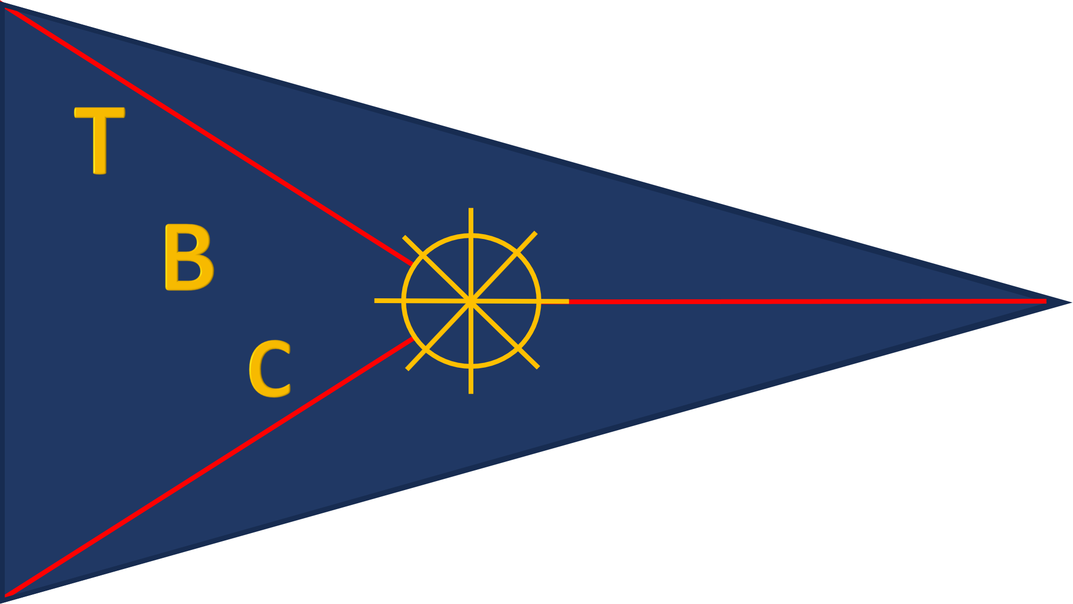
TAWE BOATING CLUB

MINUTES FOR THE CLUB SGM ON THE SUBJECT OF AGED DEBTORS, HELD AT TAWE BOATING CLUB, ON 1ST NOVEMBER 2025 AT 17:00

Present: Adam Clamp, Paul Derges, Dan Sims, Charlie Morris, Geraint Owen, Richard Cutter, Tom Norman, Curtis Lambert, Andrew Williams, Peter Baldelli, Paul Phillips, Neil Phillips, Robert Child, Kieran Davies, Florin Condurache
Apologies:

Speaker | Issue | Action
Item 1. Chairman’s Report  Adam Clamp | - Opening Remarks. The chairman welcomed the membership and thanked them for their attendance.  - The chairman set out that this meeting was not a disciplinary meeting and as was set out in the invitation was a meeting purely to discuss the recovery of an outstanding debt from Mr PP.  - Mr P.P has not paid any fees for 25-26 and now has an outstanding debt of £416.  - Letters have been sent to Mr P.P informing him that the club would take action if the debt was not settled.  - The meeting was then disrupted by Mr P.P and Mr N.P, who swore at the chairman.  - Mr P.P and Mr N.P stated that there were no fees owed due to past service to the club. They did not present any contract of employment, nor invoices for work carried out on behalf of the club which leaves a legal question over money or Free yard space being taken without the club having visibility.  - The chairman gave Mr NP a verbal warning that due to huis continued disruption, a vote would be taken at the next committee meeting on his continued membership.  - The chairman was unable to get his proposed actions across due to the disruption caused by Mr N.P and PP.  - It was proposed by Mr G.O that the club leave the debt and that from Feb 2026 Mr P.P would pay for his boat.  - The Chairman agreed that this was one of the courses of action that he was going to propose had the meeting not been disrupted.  - A vote was taken on this course of action, and was passed all in favor.  - The Chairman reiterated to Mr P.P that he was expected to pay as a full member from Feb 2026 and Mr P.P agreed verbally.  - This meeting was recorded and the audio file will be held in club records for future use.  - The meeting ended | NFA

